PLANT VARIETY PROTECTION ACT

The Plant Variety Protection Act of 1970 and as amended in 1994 allows the developer of a variety to prohibit the sale of or advertising for sale of seed of that variety without permission. Under this act the developer may also require that the seed be certified. Sale of these varieties without meeting these requirements is illegal.

Ohio Certified Seed

FLY SAFE SEEDING DATES
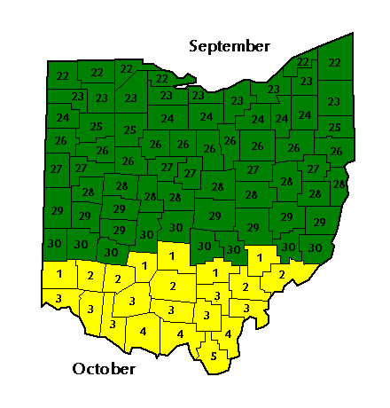


Ohio Seed Improvement Association
6150 Avery Road, Box 477
Dublin, Ohio 43017-0477
Telephone: 614-889-1136

Fax: 614-889-8979
Web Site: http://www.ohseed.org

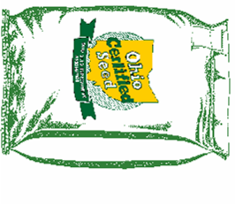

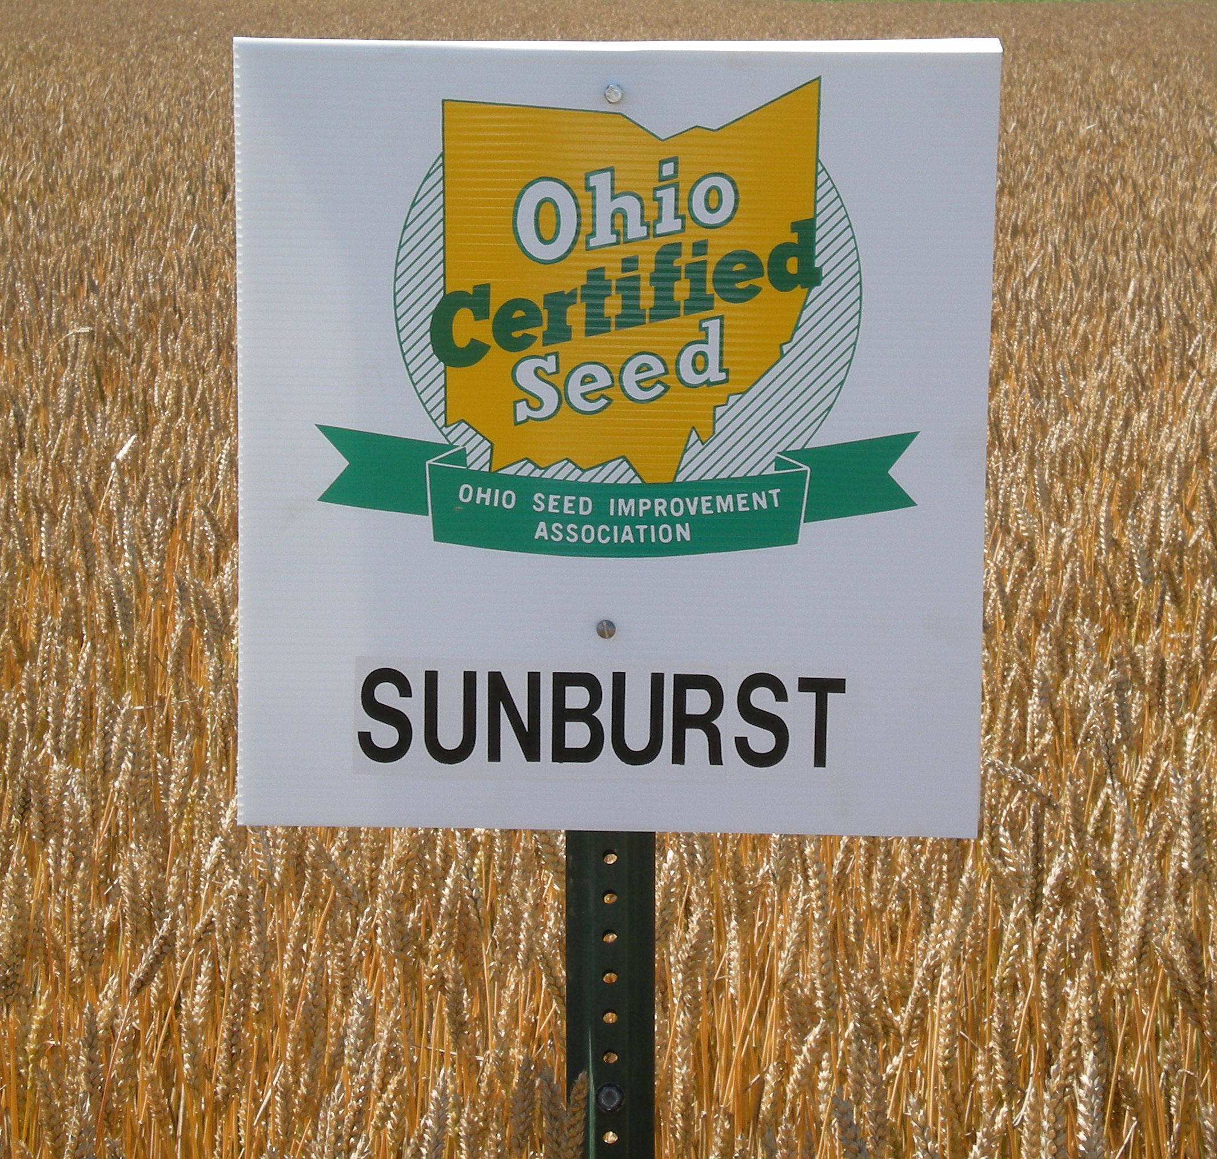
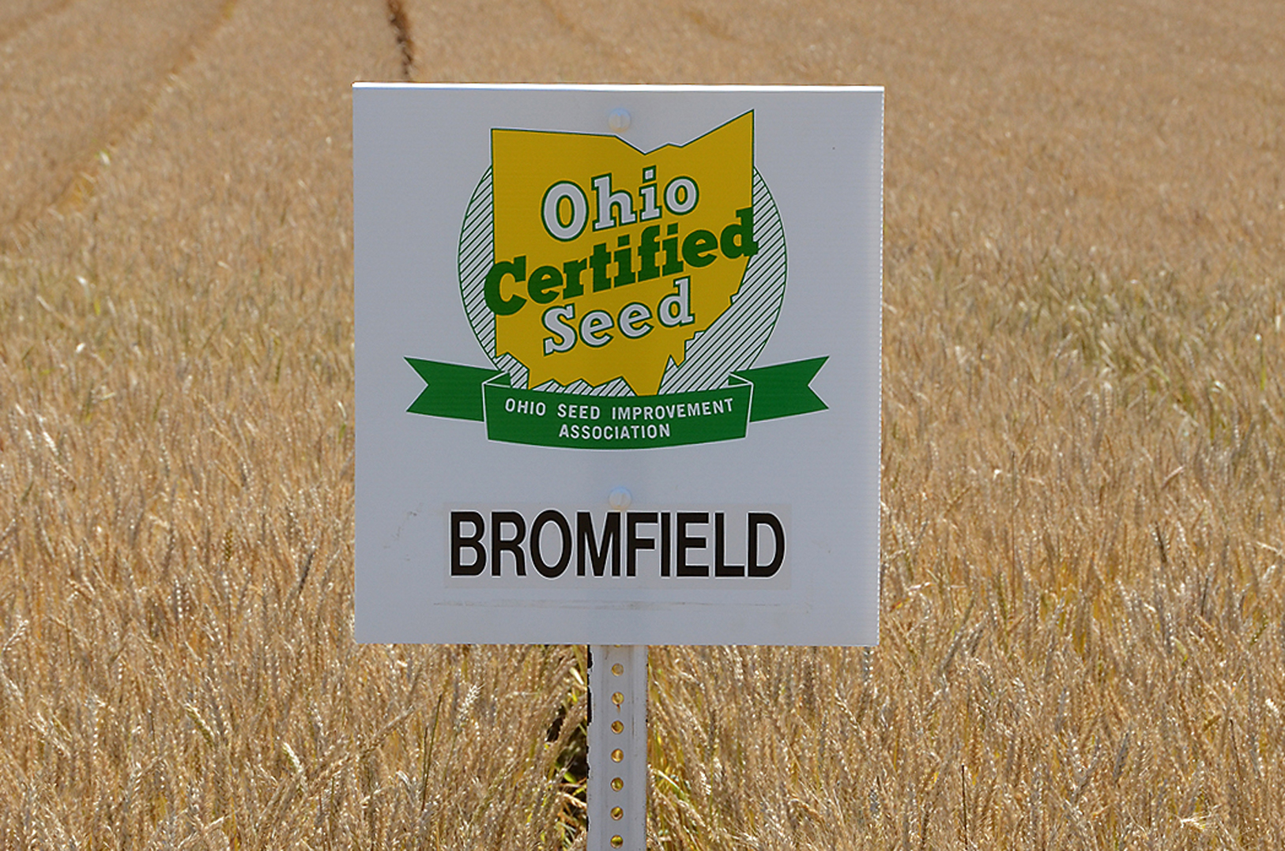

Ohio Seed Improvement Association
6150 Avery Road, Box 477
Dublin, Ohio 43017-0477
Telephone: 614-889-1136

Fax: 614-889-8979
Web Site: http://www.ohseed.org

2013 OHIO WHEAT PERFORMANCE RESULTS1

Wood CrawfoRd WAYNE darke pickaway SUMMARY
Yield Yield Yield Yield YIELD Yield TEST plant head
VARIETY Bu./AC. Bu./Ac. Bu/ac. Bu/Ac. BU/AC. Bu/ac. Weight FHB* Height date
BRAVO 57.5 83.4 86.8 82.2 87.9 79.5 58.0 MR 35 140
BROMFIELD 58.6 81.5 85.5 84.4 88.0 79.6 57.5 MR 35 144
HOPEWELL 63.1 78.2 83.8 85.2 89.5 80.0 56.1 MS 34 143
MALABAR 39.0 70.2 70.1 82.4 80.3 68.4 57.0 MR 35 144
ROANE 61.3 78.2 85.3 81.9 81.9 77.0 59.4 S 30 144
SUNBURST 70.7 95.1 93.4 93.2 88.3 88.1 59.3 S 28 143
SY 483 65.6 93.8 94.5 99.1 94.7 89.5 56.4 S 31 144
SY 1526 54.5 71.9 83.5 84.3 84.5 75.7 57.4 MR 32 141
W1104 42.4 84.5 90.3 88.1 83.8 77.8 55.9 MR 31 142

OTHER VARIETAL CHARACTERISTICS

DISEASE RATINGS²
VARIETY RELEASE STRAW TEST WINTER LEAF POWDERY GLUME WHEAT HESSIAN
INFORMATION STRENGTH WEIGHT HARDINESS RUST MILDEW BLOTCH MOSAIC FLY
Bravo 2000-C.O.S.T. Excellent High Excellent S MS MS R Poor
Bromfield 2008-Ohio Excellent Very Good - - MR MS - -
GR962 1992-Ohio Excellent Medium Excellent S MS S - -
Hopewell 1992-Ohio Excellent Medium Excellent S MR MR R Poor
Malabar 2008-Ohio Good Good - - MS MS - -
Roane 1998-Virginia Tech Good Very Good Very Good MR S MR G Good
Shirley 2008-Virginia Tech Excellent Good Good R R MS R Good
Sunburst 2007-C.O.S.T. Excellent Excellent Excellent R MR MS - MR
SY 483 Syngenta Seeds - - - MR MS MS - -
SY 1526 Syngenta Seeds - - - MR S MR MR -
Truman 2003 Univ. MO. Good High Good MR MS R MS Poor
W1104 Syngenta Seeds - - - MR MS MS MR -
W1377 Syngenta Seeds - High - MR S - - R

1All yield data from Ohio State University, Department of Horticulture and Crop Science, Series 228, July 2013.
2S - Susceptible; MS - Moderately Susceptible; MR - Moderately Resistant; R - Resistant; E - Excellent; VG - Very Good; G - Good; F – Fair. Ratings based on a combination of company release notices and university ratings. Reactions scored during 2009 - 2012. Obtain new information each year due to expected changes in reactions over time.
*Fusarium Head Blight Rating (FHB)

